UK Banks Data

Data Information:

***Customer ID:***

This is one type of primary key in the data as we know that all the customers have unique customer ID and according to that id only, we can recognize the customer and get the details of that respective customer.

***Name:***

Name is a type of nominal attribute as we cannot get any insights from the name of the customers as they are only use to identify the person.

***Surname:***

Surname is also a type of nominal attribute.

***Gender:***

Gender is classified as a nominal attribute but is used to get the insight what is the percentage of male and female are employed or unemployed and what type of job is there i.e., white collar, blue collar or any other

***Age:***

Age is both nominal or ordinal attribute based on the data. Here the age is an important aspect as we can get the people salary according to their age and classify in different sets of groups.

***Region:***

Here region refers to from where the person belongs i.e., in which country the person is living and is employee or unemployed.

***Job Classification:***

In the data job classification is been divided into 3 classes mainly:

1. White collar
2. Blue collar
3. Other (means a person who is working on regular wages)

***Date Joined:***

It means on what date the person had joined the job

***Balance:***

What is the balance in their account and we can classify on the basis of their balance!

***Link of Dataset:***

<https://sds-platform-private.s3-us-east-2.amazonaws.com/uploads/P1-UK-Bank-Customers.csv>

***Map:***

Here mainly 4 cities are taken of UK for analysis 1. England ,2. Northern Ireland ,3. Scotland,

4. Wales

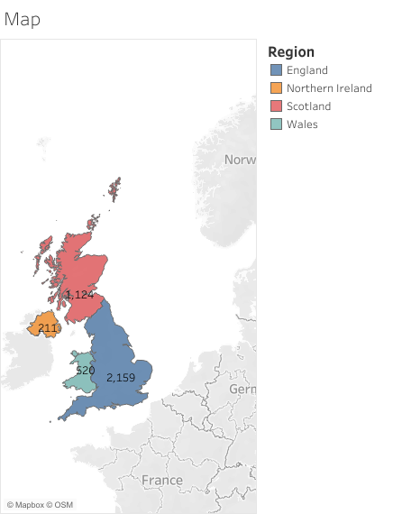

***Gender:***

Here as we can see that the 54% are men who are employed and 46% women are employed

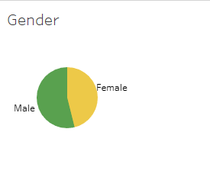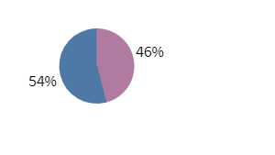

***Age Distribution:***

Mostly the person having age between 30-45 are employed.

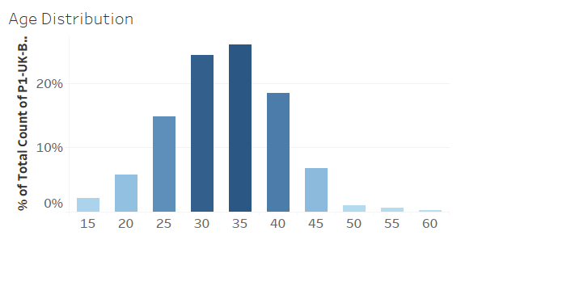

***Bank Balance:***

Here we can see that most of the person i.e., around 15.9% are having no source of income.

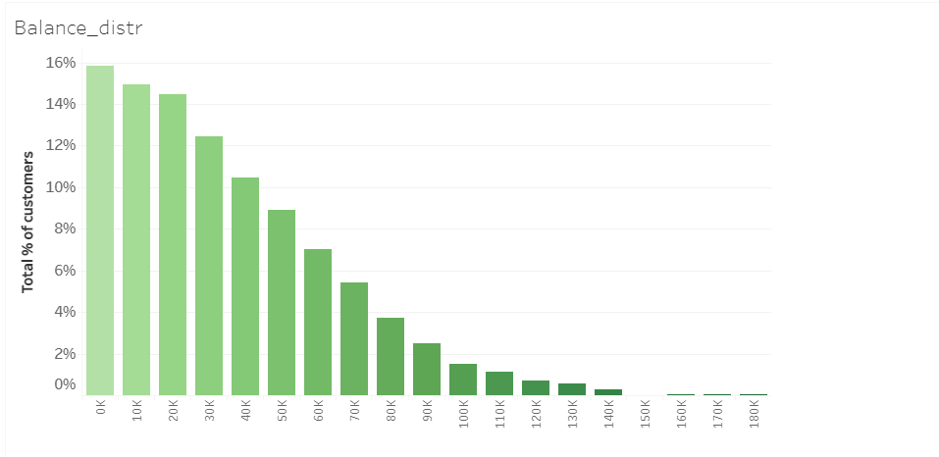

***Job Classification:***

Most of the job is white collar job and after it comes the Blue-collar job.

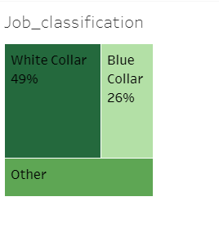 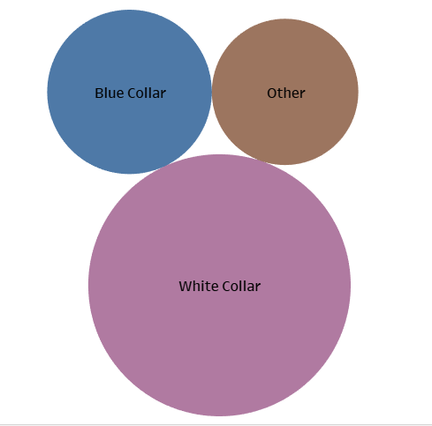

***Gender wise Age distribution:***

.All over according to the data of 4 country we can see that age group belonging to 30-40 are employeed and out of that there are 54% are men and 46% are women

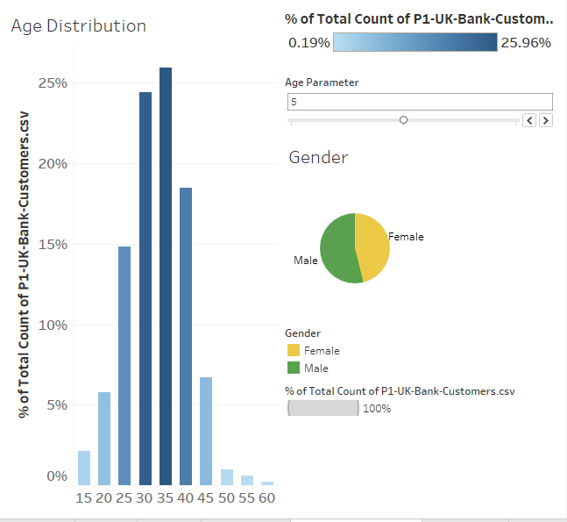

***Gender Distrbution according to the country:***

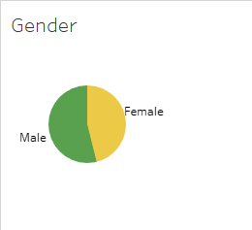

**England: Scotland:**

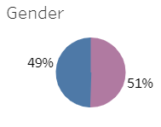 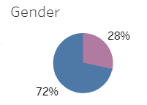

**Wales: North Ireland:**

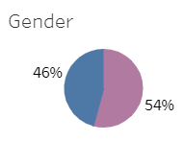 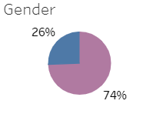

***Job Description according to Country (5000 people):***



**England: Scotland:**

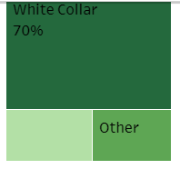 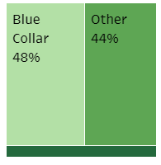

**Wales: Northern Ireland:**

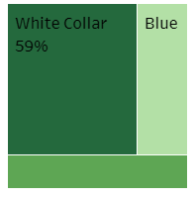 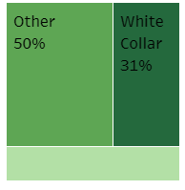

***England:***

Here we have represented the data of the england customers.

Here we can see that:

1. Around 70% of the jobs are white collar job
2. The people belonging to the 30s age are having the white collar job.
3. We can also see that 40% of the people are having no source of income.

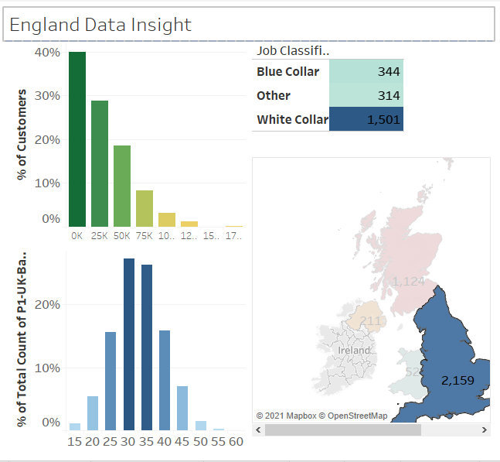

***North Ireland:***

Here we have represented the data of the North Ireland customers.

Here we can see that:

1. As a small country it has less number of job and that the jobs are on regular wages on the basis of their day to day work.
2. Most of the people belong to age group of 25.

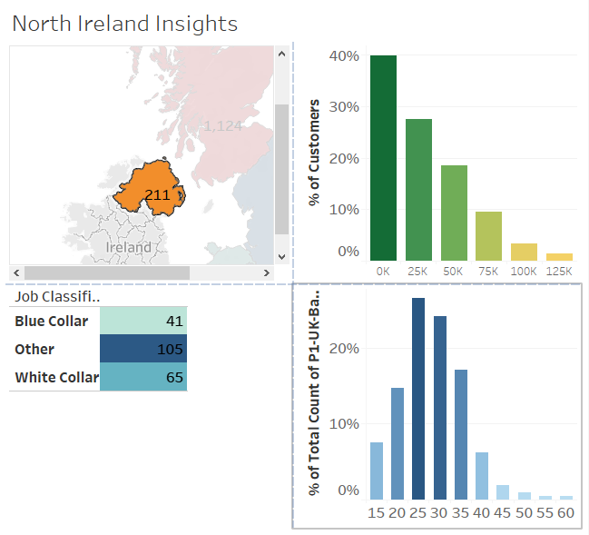

.

***Scotland:***  
Here we have represented the data of the england customers.

Here we can see that:

1. 48% of the job are blue collar job.
2. 44% jobs belong to the regular wage employer.
3. Age group of 50s are employeed people that means the aged person are working hard to live their life in Scotland.

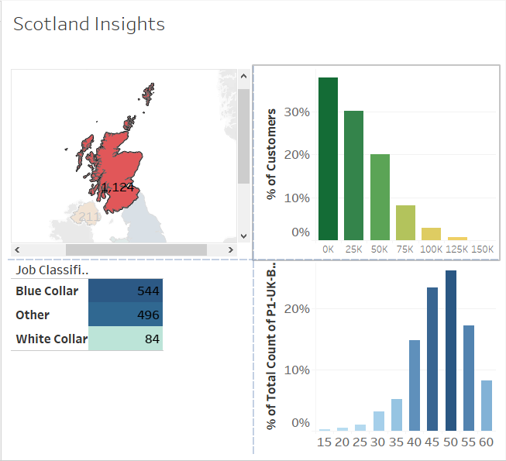

***Wales:***

Here we have represented the data of the england customers.

Here we can see that:

1. 59% job are while collar job.
2. Age group of 35s are employed.

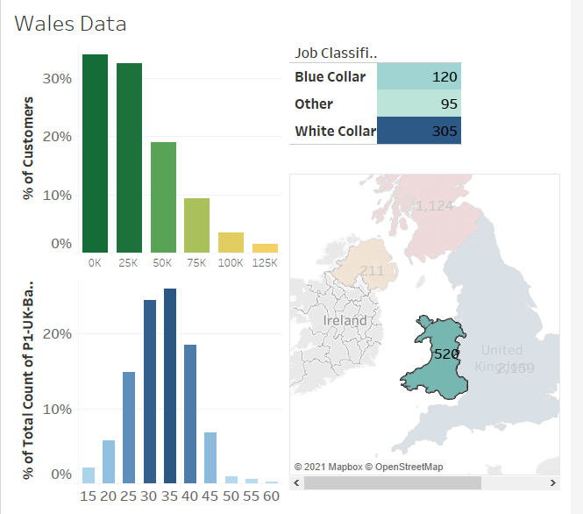

***Overall Report from the dataset: (for 5000 people) :***

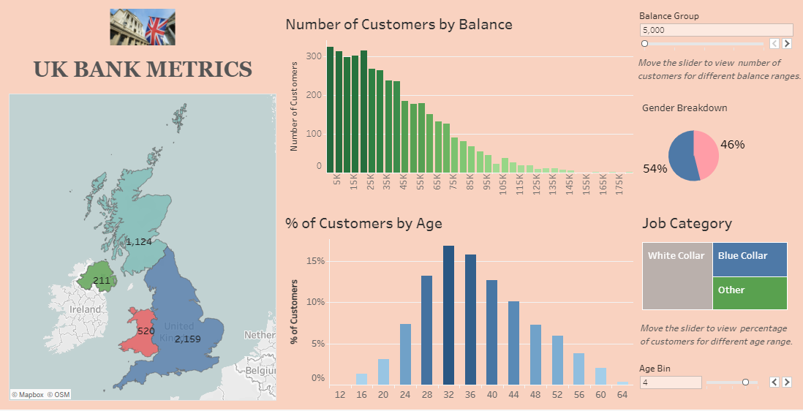

* 4 Countries
* Maximum number of people employed: Age: 30-35
* Out of 5000 more than 300 people are unemployed, 310 people earn 5K, 315 people earn 15K and it is clearly seen that are the money is increasing the people belonging to that group are also decreasing. So, we can say that bank balance is inversely proportional to the employed people.
* Out of 5000 people:

1955 job -> White collar job

1049 job -> Blue collar job

1010 job -> Other job

* 54% employee people are men, 46% employee are women.

***The Bank Customer Baseline:***

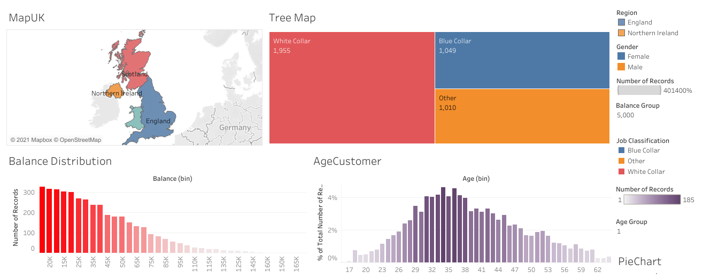

***Details:***

* England has most of the job which belon to white collar job (70%).
* Mostly customers of Scotland belong to the blue collar (48%) and other types of job (44%).
* Data for whale shoe and above average representation of mid-size balance.
* Insights for the Northern Ireland represents that most of the customers belong to female group.

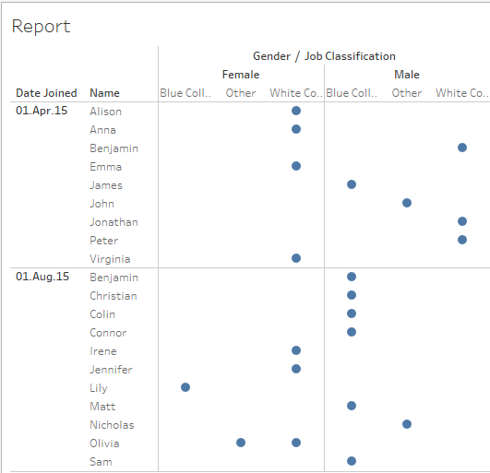

***As above we can see that:***

**1st April 2015:**

* Alison is female and she joined a White-collar job.
* Benjamin is male and he joined a White-collar job.
* James is male and he joined a Blue-collar job.
* Similarly for others we can also see.

**1st August 2015:**

* Colin is male and he joined Blue-collar job.
* Nicholas is male and he is working on regular wages.
* Olivia is female and she joined a White-collar job.